**LAB6**

**Step 69\***. Under Component Name, locate

**RedshiftLoadActivity** and use the arrow symbol to view the

activity details..

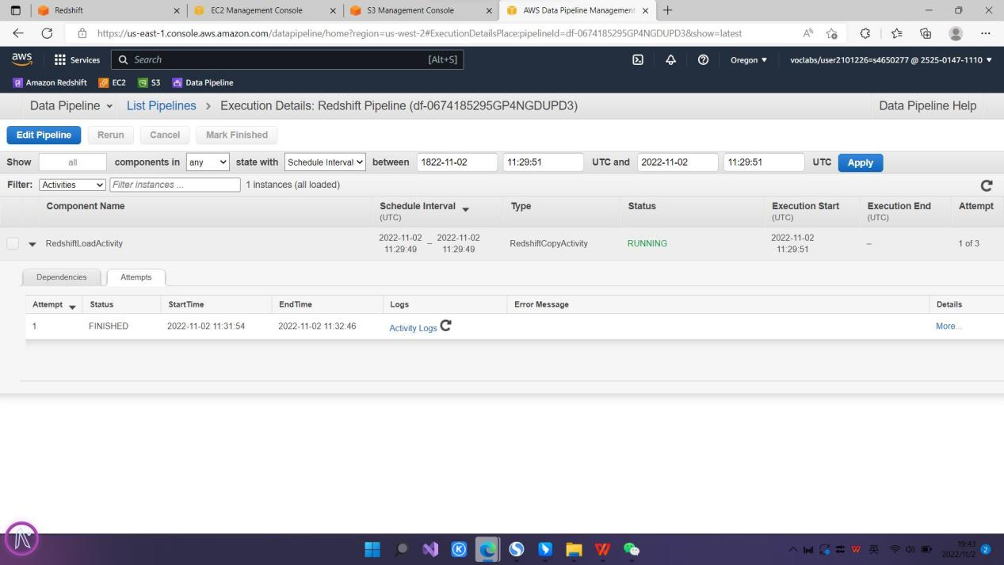

**Step 80.** Choose the three dots next to the *jan* table and

choose Preview data.

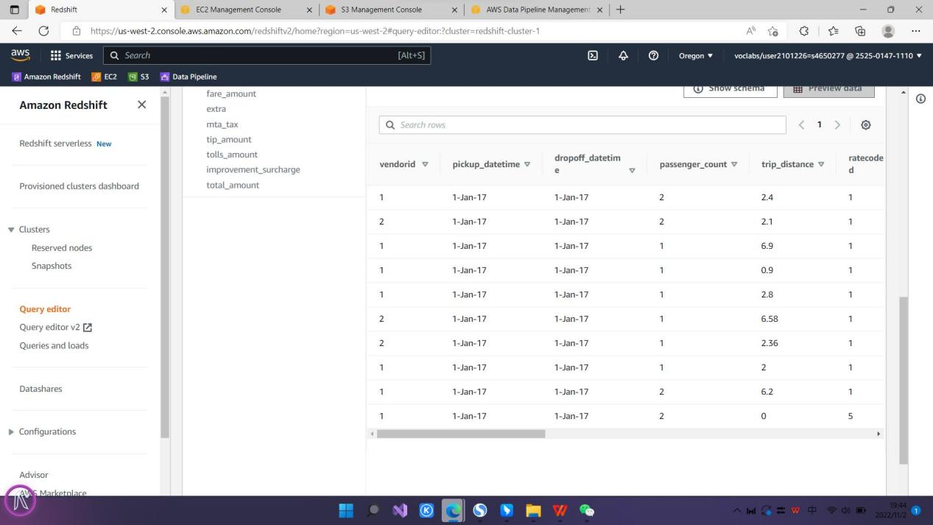

**Challenge question**

Your manager is pleased that you automated the process of

loading data to Amazon Redshift. He would now like you to

do two additional tasks:

• Create a pipeline that will load a second month of data.

• Determine the most common pickup locations for each

of the two months

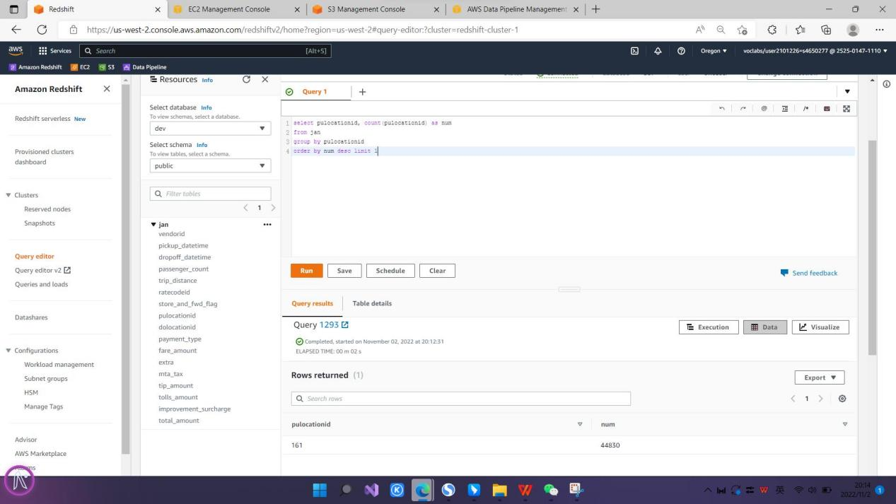

LAB7

**Step 54.** You see a pie chart similar to the following image:

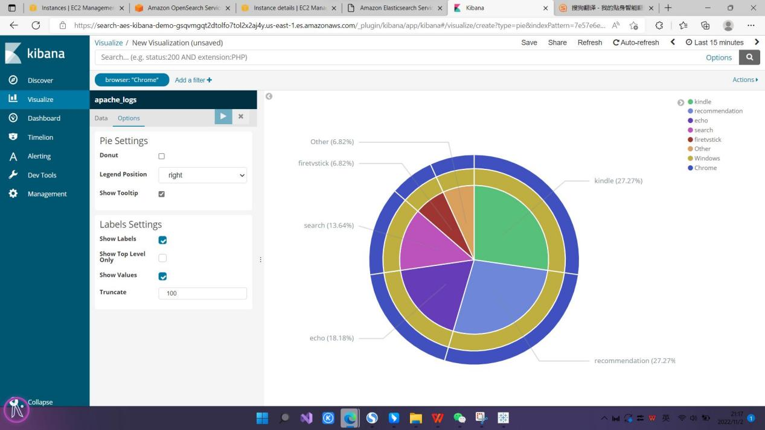

**Step 70.** To apply the changes, choose the blue arrow. You

will see a heat map that shows the number of webpage

views and the number of referrals to those pages from the

Webpages

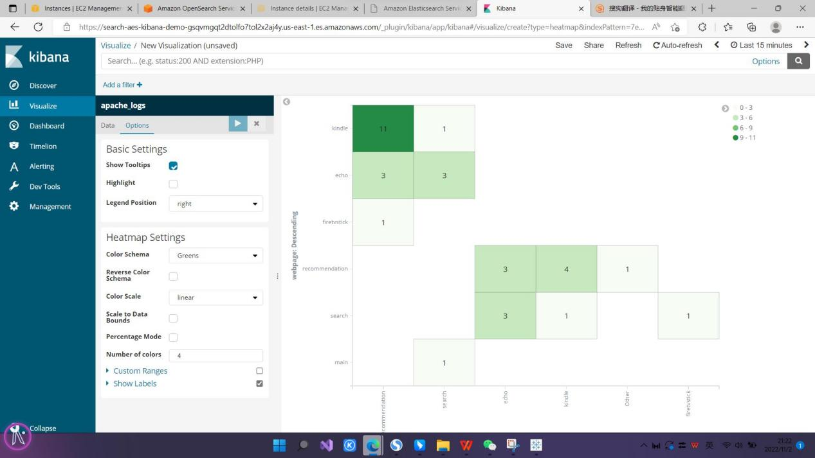

**Challenge one**

Create a line visualization that shows the number of page

views for the webpages.

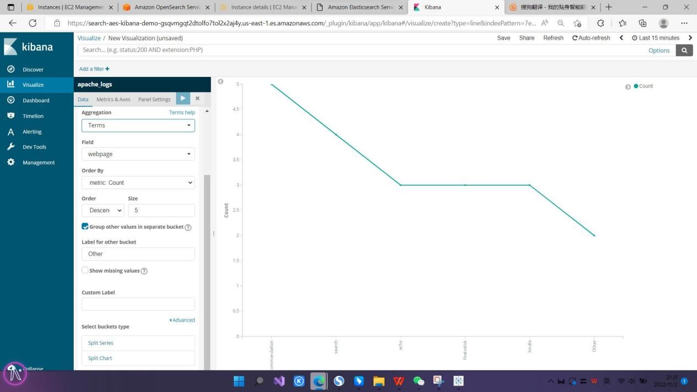

**Challenge two**

Create a bar chart visualization that shows the number of

page views for the webpages

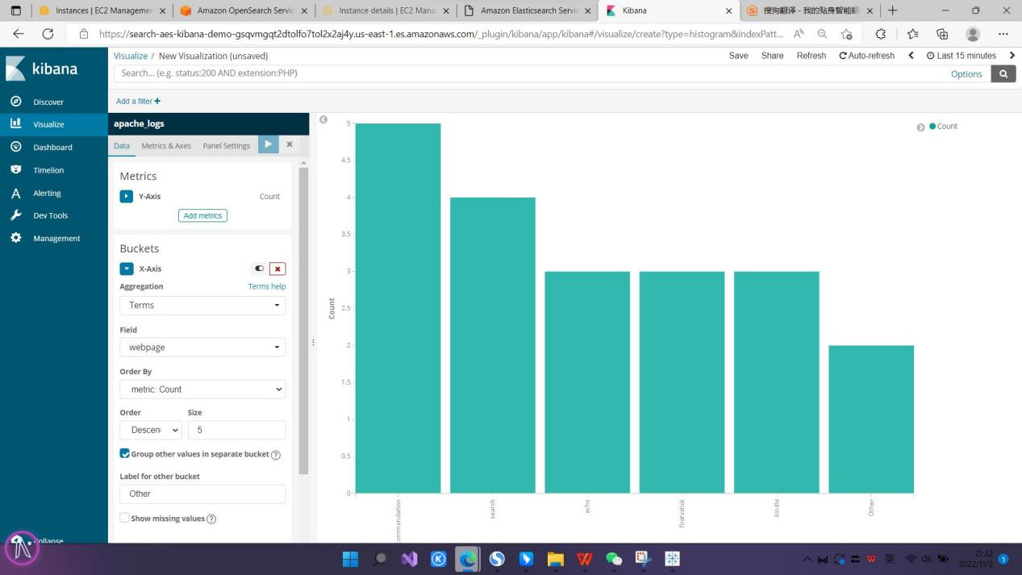

LAB8

**Step 125.** To view the results from creating the dataset,

choose **Content**. You will see the **Result preview**, which is

the average maximum temperature in the dataset. The value

will be ***8.429***

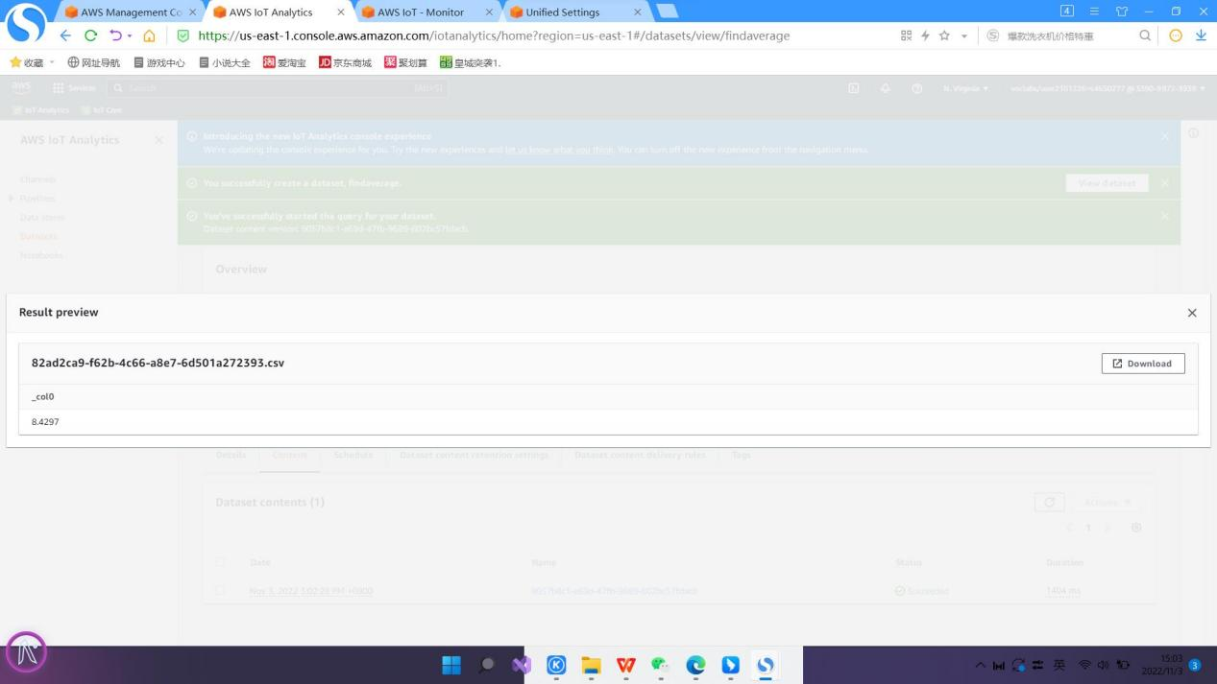

**Challenge question**

For this challenge, create a dataset to find the average

temperature for a specific location.

**\*** FULL screes must include one element: (6) taskbar date

and time

